Written Assignment Unit 4
Learning Journal Unit 4
1. Start Wireshark capture.
2. Open a web browser and visit http://www.example.com/
3. Stop the Wireshark capture and answer the following questions with screenshots attached for each:
a. Identify the TCP 3-way handshake interaction.
b. What is the MAC address of your PC as shown in Wireshark?
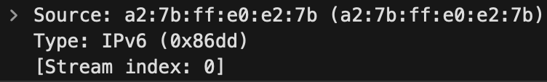
- My PC’s MAC Address: a2:7b:ff:e0:e2:7b
c. Which vendor manufactured the network card on your PC? Use the PC MAC address as shown in Wireshark.
- Vendor’s MAC address a2:7b:ff:e0:e2:7b
d. What is the MAC address of your gateway device as shown in Wireshark?
- Gateway MAC Address: a8:50:81:b2:5d:02 (Source MAC, identified as Huawei Technologies)
e. What is the IP address of your PC as shown in Wireshark?
- IP Address: 192.168.1.107 (Destination IP)
f. What version of HTTP is captured?
- No HTTP request was captured.
g. What is your PC’s operating system (OS) platform as shown in Wireshark?
Did not show language since the HTTP protocol was not captured. But I am using MacOS.
h. What language is your PC’s browser configured to as shown in Wireshark?
Did not show language since the HTTP protocol was not captured.
4. You are to save and submit your Wireshark capture file. Add screenshots for all questions from 3a-3h along with their answers in MS Word or PDF file and submit the same.

